- Set username and email
  - 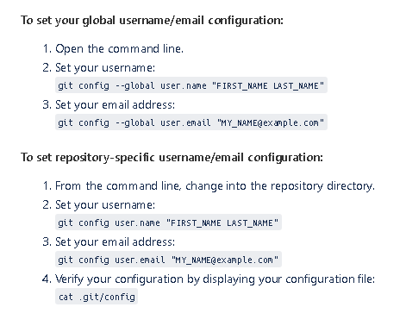
  - You can check your set user name and email by running below commands
    - Git config user.name
    - Git config user.email
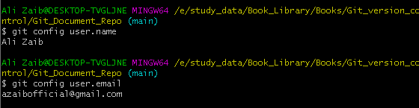
- Remove previous repo username and password and login new repon in git base
  - Use below command
    - rundll32.exe keymgr.dll, KRShowKeyMgr
    - run the above command and git bash will direct you to browser to get authentication
- Start a working directory
  - Clone: Clone a repository into a new directory
  - init: Create an empty Git repository or reinitialize an existing

- work on current changes
  - add: Add file contents to the index
  - mv: Move or rename a file, a directory, or a symlink
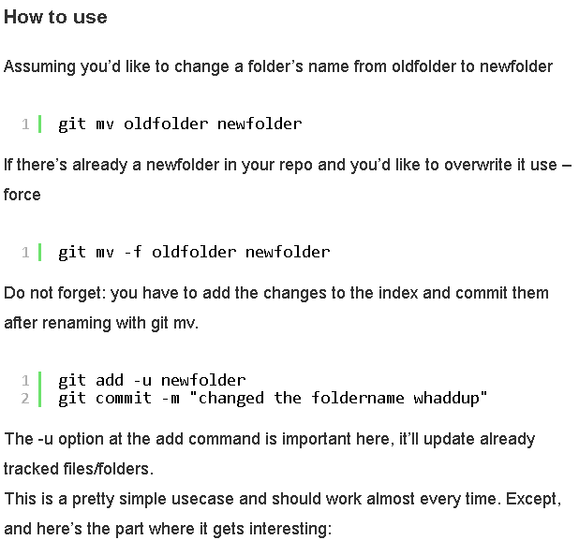
  - reset : Reset current HEAD to the specified state
    - use to unstage files
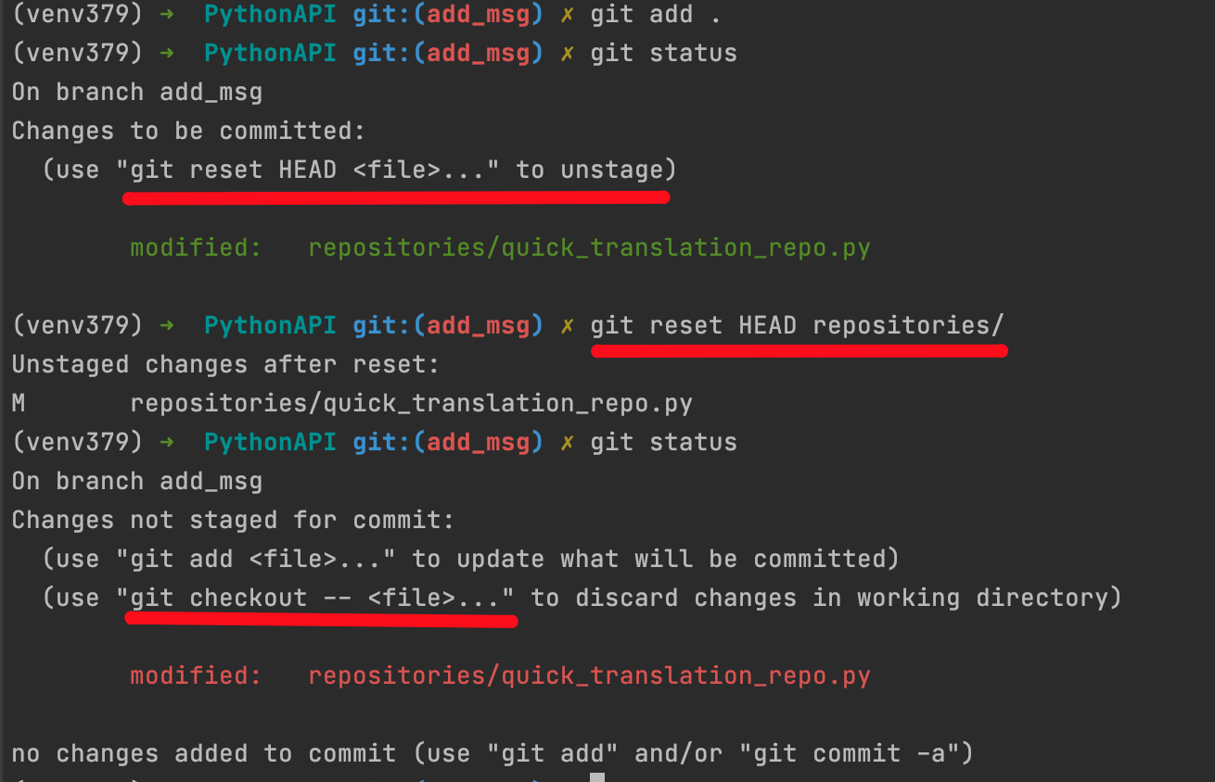
To discard changes in file
git checkout -- file_name
to discard changes from all files
git checkout -- .
after that you will get message
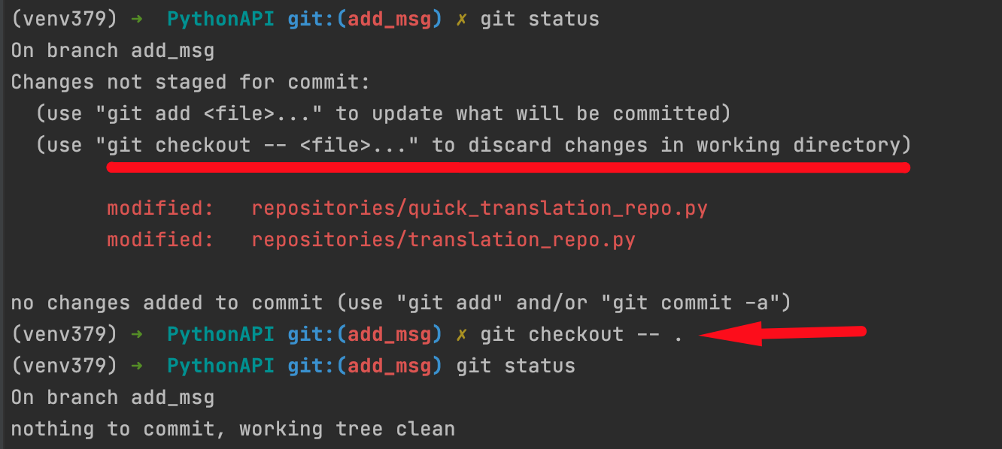
  - rm: Remove files from the working tree and from the index
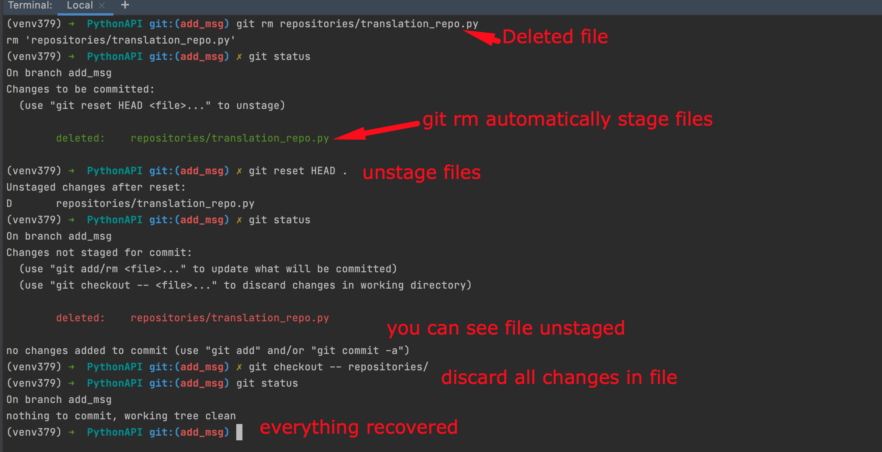

- grow, mark and tweak your common history
  - branch List, create, or delete branches
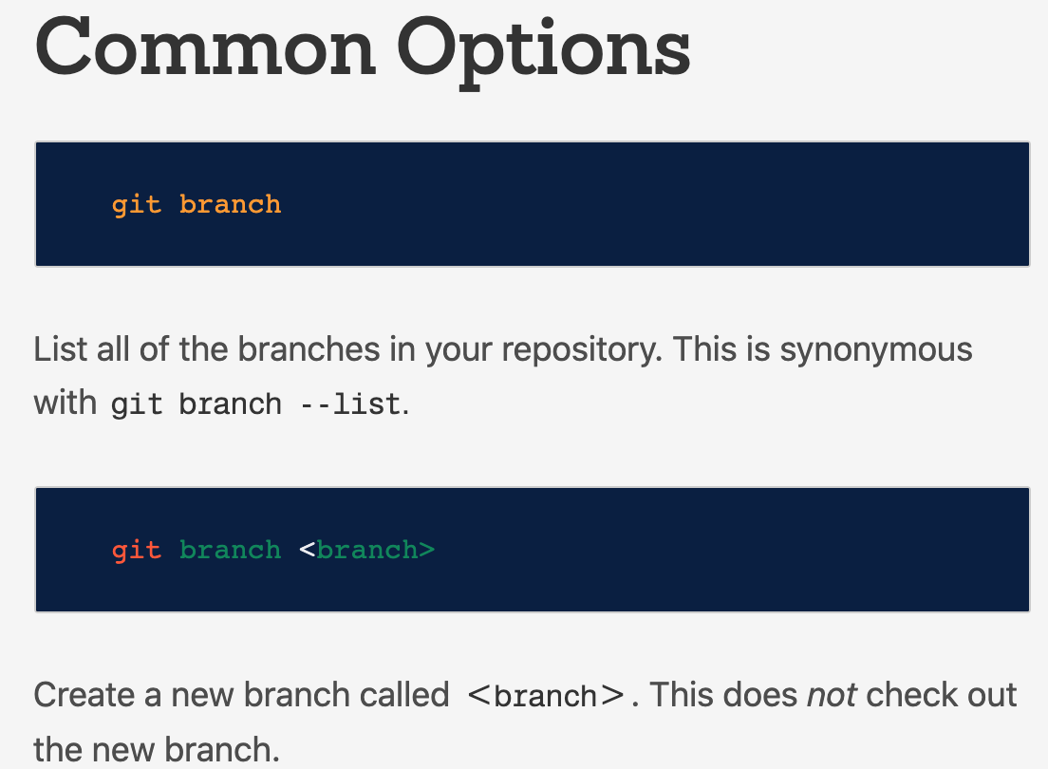
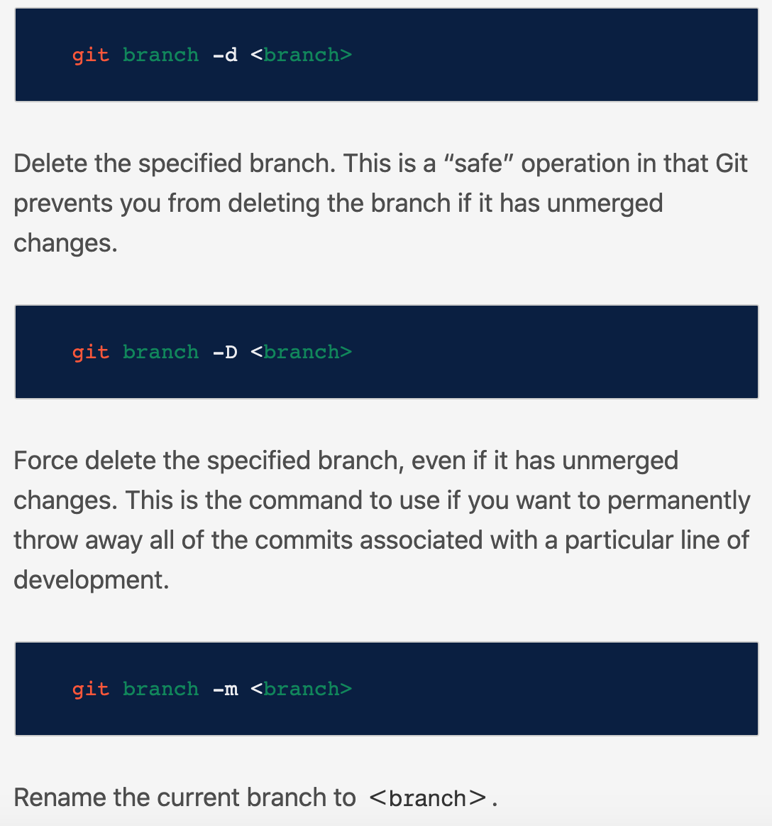
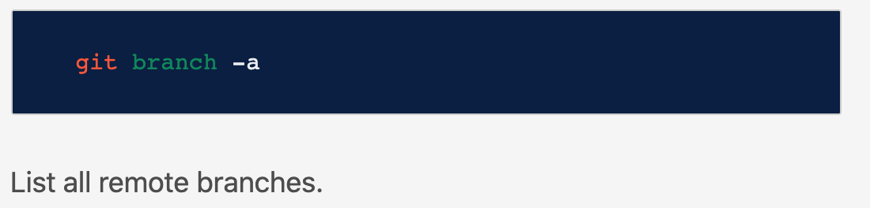

  - commit Record changes to the repository
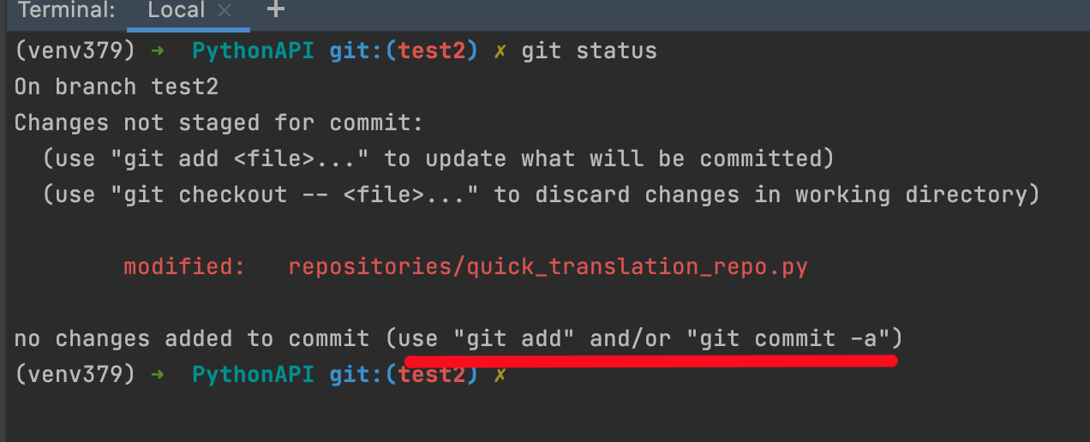
git add: I already know

git commit -a: it automatically add all changes to staging open text editor for message.
  - merge Join two or more development histories together

Git merge will combine multiple sequences of commits into one unified history. In the most frequent use cases, git merge is used to combine two branches.

The following examples in this document will focus on this branch merging pattern.

In these scenarios, git merge takes two commit pointers, usually the branch tips, and will find a common base commit between them. Once Git finds a common base commit it will create a new "merge commit" that combines the changes of each queued merge commit sequence.

Say we have a new branch feature that is based off the master branch. We now want to merge this feature branch into master.

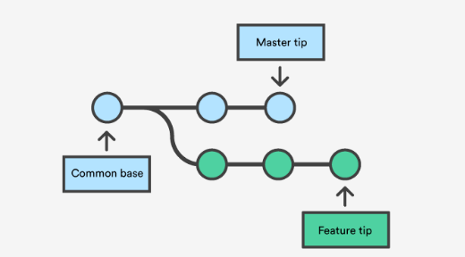

Invoking this command will merge the specified branch feature into the current branch, we'll assume master. Git will determine the merge algorithm automatically (discussed below).

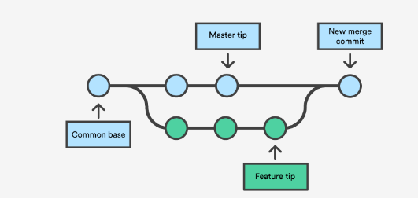

Merge commits are unique against other commits in the fact that they have two parent commits.
- One is from feature branch
- One is from parent branch

When creating a merge commit Git will attempt to auto magically merge the separate histories for you.
If Git encounters a piece of data that is changed in both histories it will be unable to automatically combine them. This scenario is a version control conflict and Git will need user intervention to continue.

Preparing to merge

- Confirm the receiving branch(the branch that will contain all new changes). E.g. main branch
  - Run the git status: and check is head pointing to right branch.
- Make sure that receiving branch and merging branch are up to date with latest remote changes.
  - Execute git fetch to pull latest changes
- When all changes done run
  - Git merge br.name(e.g feature branch that you want to merge in main branch)
- Fast Forward Merge?
  - A fast-forward merge can occur when there is a linear path from the current branch tip to the target branch. Instead of “actually” merging the branches, all Git has to do to integrate the histories is move (i.e., “fast forward”) the current branch tip up to the target branch tip. This effectively combines the histories, since all of the commits reachable from the target branch are now available through the current one. For example, a fast forward merge of some-feature into master would look something like the following:
  - 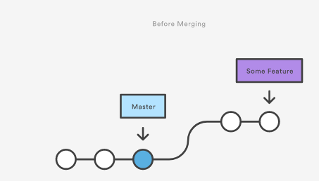
  - 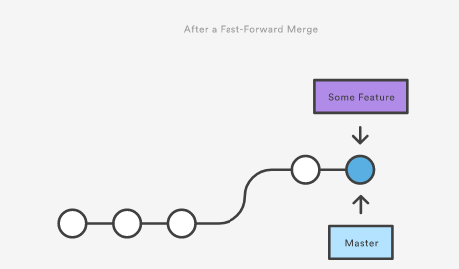
  - a
- However, a fast-forward merge is not possible if the branches become separate.
  - When there is not a linear path to the target branch, Git has no choice but to combine them via a 3-way merge. 3-way merges use a dedicated commit to tie together the two histories. The nomenclature comes from the fact that Git uses three commits to generate the merge commit: the two branch tips and their common ancestor.
  - 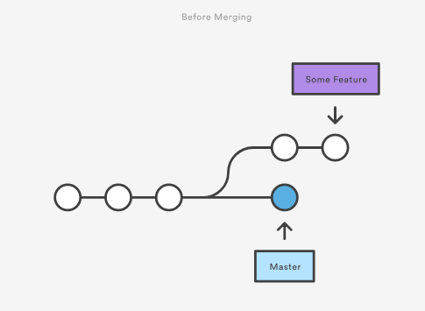
  - 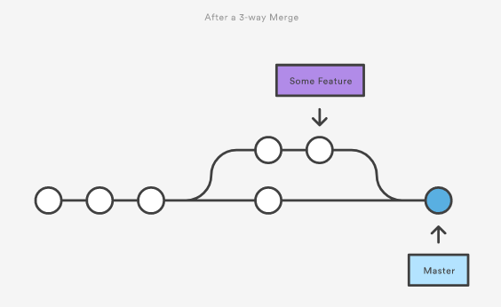

- While you can use either of these merge strategies, many developers like to use fast-forward merges (facilitated through rebasing) for small features or bug fixes, while reserving 3-way merges for the integration of longer-running features. In the latter case, the resulting merge commit serves as a symbolic joining of the two branches.
- Our first example demonstrates a fast-forward merge. The code below creates a new branch, adds two commits to it, then integrates it into the main line with a fast-forward merge.
  - 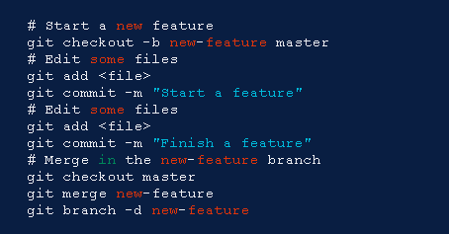
  - This is a common workflow for short-lived topic branches that are used more as an isolated development than an organizational tool for longer-running features.
  - Also note that Git should not complain about the git branch -d, since new-feature is now accessible from the master branch.
- For fast forward commit
  - In the event that you require a merge commit during a fast forward merge for record keeping purposes you can execute git merge with the --no-ffoption
  - 
- 3-way merge
  - The next example is very similar, but requires a 3-way merge because master progresses while the feature is in-progress. This is a common scenario for large features or when several developers are working on a project simultaneously.
  - 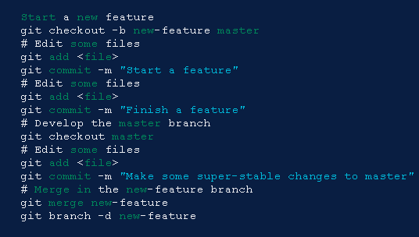
  - Note that it’s impossible for Git to perform a fast-forward merge, as there is no way to move master up to new-feature without backtracking.

- Resolving conflict
  - If the two branches you're trying to merge both changed the same part of the same file, Git won't be able to figure out which version to use. When such a situation occurs, it stops right before the merge commit so that you can resolve the conflicts manually.
  - The great part of Git's merging process is that it uses the familiar edit/stage/commit workflow to resolve merge conflicts. When you encounter a merge conflict, running the git status command shows you which files need to be resolved. For example, if both branches modified the same section of hello.py, you would see something like the following:
  - 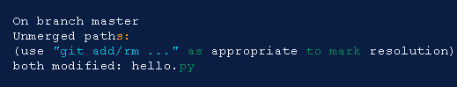
  - A
- How conflicts are presented
  - When Git encounters a conflict during a merge, It will edit the content of the affected files with visual indicators that mark both sides of the conflicted content. These visual markers are: <<<<<<<, =======, and >>>>>>>. Its helpful to search a project for these indicators during a merge to find where conflicts need to be resolved.
  - 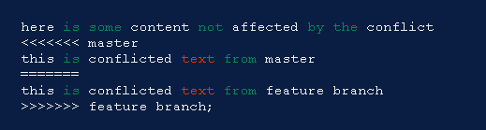
  - Generally the content before the ======= marker is the receiving branch and the part after is the merging branch.
  - Once you've identified conflicting sections, you can go in and fix up the merge to your liking. When you're ready to finish the merge, all you have to do is run git add on the conflicted file(s) to tell Git they're resolved. Then, you run a normal git commit to generate the merge commit. It’s the exact same process as committing an ordinary snapshot, which means it’s easy for normal developers to manage their own merges.
  - Note that merge conflicts will only occur in the event of a 3-way merge. It’s not possible to have conflicting changes in a fast-forward merge.
- Summary
  - Merging is an essential process when working with Git. We discussed the internal mechanics behind a merge and the differences between a fast forward merge and a three way, true merge. Some key take-aways are:
    - Git merging combines sequences of commits into one unified history of commits.
    - There are two main ways Git will merge: Fast Forward and Three way
    - Git can automatically merge commits unless there are changes that conflict in both commit sequences.

  - Git merge conflicts
    - Understanding merge conflicts
      - Merging and conflicts are a common part of the Git experience. Conflicts in other version control tools like SVN can be costly and time-consuming. Git makes merging super easy. Most of the time, Git will figure out how to automatically integrate new changes.
      - Conflicts generally arise when two people have changed the same lines in a file, or if one developer deleted a file while another developer was modifying it. In these cases, Git cannot automatically determine what is correct.

Conflicts only affect the developer conducting the merge, the rest of the team is unaware of the conflict.

Git will mark the file as being conflicted and halt the merging process. It is then the developers' responsibility to resolve the conflict.
    - Types of merge conflicts
      - A merge can enter a conflicted state at two separate points. When starting and during a merge process.
    - Git fails to start the merge
      - A merge will fail to start when Git sees there are changes in either the working directory or staging area of the current project.

Git fails to start the merge because these pending changes could be written over by the commits that are being merged in. When this happens, it is not because of conflicts with other developer's, but conflicts with pending local changes.

The local state will need to be stabilized using git stash, git checkout, git commit or git reset. A merge failure on start will output the following error message:

error: Entry '<fileName>' not uptodate. Cannot merge. (Changes in working directory)
    - Git fails during the merge
      - A failure DURING a merge indicates a conflict between the current local branch and the branch being merged. This indicates a conflict with another developers code. Git will do its best to merge the files but will leave things for you to resolve manually in the conflicted files. A mid-merge failure will output the following error message:

error: Entry '<fileName>' would be overwritten by merge. Cannot merge. (Changes in staging area)

    - Creating a merge conflict
      - Lets implement
$ mkdir git-merge-test
$ cd git-merge-test
$ git init .
$ echo "this is some content to mess with" > merge.txt
$ git add merge.txt
$ git commit -am"we are commiting the inital content"
[master (root-commit) d48e74c] we are commiting the inital content
1 file changed, 1 insertion(+)
create mode 100644 merge.txt
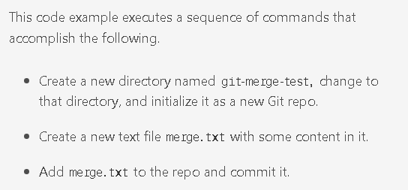
      - Now we have a new repo with one branch master and a file merge.txt with content in it. Next, we will create a new branch to use as the conflicting merge.
$ git checkout -b new_branch_to_merge_later
$ echo "totally different content to merge later" > merge.txt
$ git commit -am"edited the content of merge.txt to cause a conflict"
[new_branch_to_merge_later 6282319] edited the content of merge.txt to cause a conflict
1 file changed, 1 insertion(+), 1 deletion(-)
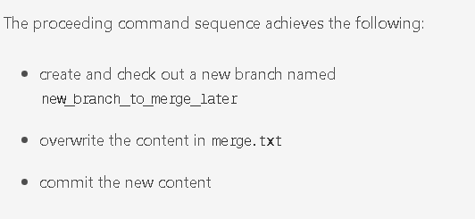
      - With this new branch: new_branch_to_merge_later we have created a commit that overrides the content of merge.txt
git checkout master
Switched to branch 'master'
echo "content to append" >> merge.txt
git commit -am"appended content to merge.txt"
[master 24fbe3c] appended content to merge.tx
1 file changed, 1 insertion(+)

This chain of commands checks out the master branch, appends content to merge.txt, and commits it.

This now puts our example repo in a state where we have 2 new commits.
- One in the master branch
- one in the new_branch_to_merge_later branch.

At this time lets git merge new_branch_to_merge_later and see what happen!

$ git merge new_branch_to_merge_later
Auto-merging merge.txt
CONFLICT (content): Merge conflict in merge.txt
Automatic merge failed; fix conflicts and then commit the result.
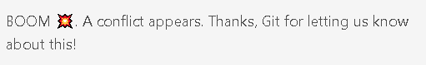

    - How to identify merge conflicts
      - As we have experienced from the proceeding example, Git will produce some descriptive output letting us know that a CONFLICT has occcured. We can gain further insight by running the git status command
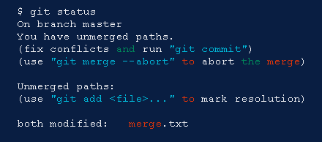

The output from git status indicates that there are unmerged paths due to a conflict.

The merge.text file now appears in a modified state. Let's examine the file and see whats modified.

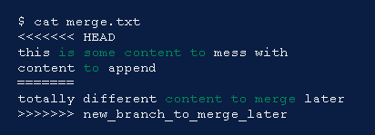

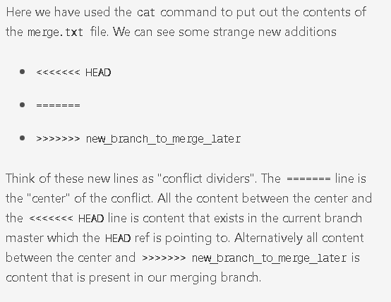
    - How to resolve merge conflicts using the command line
      - The most direct way to resolve a merge conflict is to edit the conflicted file. Open the merge.txt file in your favorite editor.

For our example lets simply remove all the conflict dividers. The modified merge.txt content should then look like:

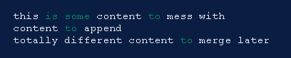

Once the file has been edited use git add merge.txt to stage the new merged content. To finalize the merge create a new commit by executing:

git commit -m "merged and resolved the conflict in merge.txt"
    - Git will see that the conflict has been resolved and creates a new merge commit to finalize the merge.

  - Git commands that can help resolve merge conflicts

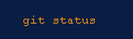
    - The status command is in frequent use when a working with Git and during a merge it will help identify conflicted files.


    - Passing the --merge argument to the git log command will produce a log with a list of commits that conflict between the merging branches.

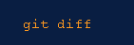
    - diff helps find differences between states of a repository/files. This is useful in predicting and preventing merge conflicts.

  - Tools for when git fails to start a merge

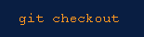
    - checkout can be used for undoing changes to files, or for changing branches

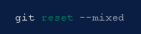
    - reset can be used to undo changes to the working directory and staging area.

  - Tools for when git conflicts arise during a merge

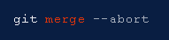
    - Executing git merge with the --abort option will exit from the merge process and return the branch to the state before the merge began.

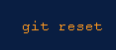
    - Git reset can be used during a merge conflict to reset conflicted files to a know good state

  - Summary
    - Merge conflicts can be an intimidating experience. Luckily, Git offers powerful tools to help navigate and resolve conflicts. Git can handle most merges on its own with automatic merging features. A conflict arises when two separate branches have made edits to the same line in a file, or when a file has been deleted in one branch but edited in the other. Conflicts will most likely happen when working in a team environment.

  - There are many tools to help resolve merge conflicts. Git has plenty of command line tools we discussed here.
    - For more detailed information on these tools visit stand-alone pages for git log, git reset, git status, git checkout, and git reset. In addition to the Git, many third-party tools offer streamlined merge conflict support features.

  - Git Merge Strategy Options and Examples
Description:
When a piece of work is complete, tested and ready to be merged back into the main line of development, your team has some policy choices to make. What are your merge strategy options? In this article we'll examine the possibilities and then provide some notes on how Atlassian operates. Hopefully at the end you'll have the tools to decide what works best for your team.
    - https://www.atlassian.com/git/tutorials/using-branches/merge-strategy

  - rebase Reapply commits on top of another base tip
  - reset Reset current HEAD to the specified state
  - switch Switch branches
  - tag Create, list, delete or verify a tag object signed with GPG

- collaborate (see also: git help workflows)
  - fetch Download objects and refs from another repository
  - pull Fetch from and integrate with another repository or a local branch
  - push Update remote refs along with associated objects
- git stashing
- what is git fetch
- how to run git pull for latest changes

Git is also known as a content-addressable file system.
what is content-addressable file system?
Git is a content-addressable filesystem. It means that at the core of Git, there is a key-value data store. You can pass any kind of content into Git and you will get a key that will allow you to retrieve the content. Objects are stored in archives and can be divided into: Blob – this is a basic data storage unit
When interacting with Git, we either manage versions of files and directories or investigate the history of a workspace.
In our system, we manage files in our system
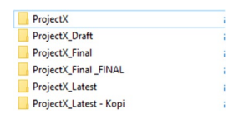
But we have now answer of the following questions when we are dealing with file system in our computer.
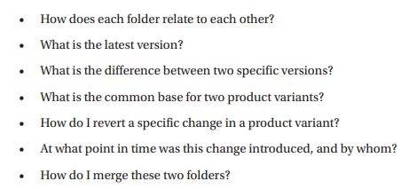

In Figure 1-2, I show how the same folders could be united in a graph of workspaces.
This allows us to maintain a sense of how our software evolves over time.

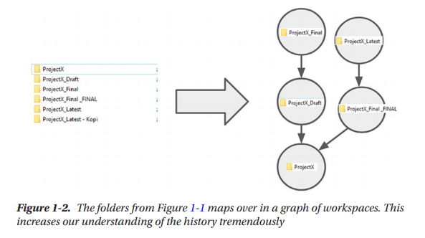
Basic Git Concepts

The Repository
When we talk about Git at the high level, we talk about collaborating in repositories.
Many software developers share their code as open source on platforms like GitHub or GitLab.

Each software project is represented by one or more repositories, depending on what strategy the organization behind the project contains. In many cases, a repository represents a single source component, such as a software library or a product you can download and run on your computer or website.
Other older vcs
- ClearCase
- SVN
There are two common ways of starting work in a repository. We can either use the command git init to initialize a new local repository without any history and start our work there. This can even be done in a folder with content that is not under version control yet. More commonly, we use the command git clone to obtain a copy of a repository. The source of a repository is most often a private (i.e., Bitbucket on premises) or public (i.e., GitHub cloud) repository manager. If we are using the clone command, we often call it cloning a repository, and we call the local instance of the repository a clone.

Open source software is often developed with a so-called “fork-based” workflow that we will cover in a later chapter. Collaboration is generally done by pushing and pulling changes between local and remote repositories.

Some commercial software development works internally using fork-based workflows.

In short, a repository is the totality of the history of a software project. That is all committed together with metadata. A repository allows you to work with version control locally and collaborate with others through remote repositories.

The Commit
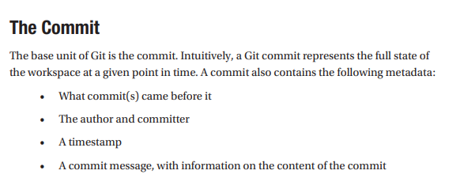

Note: Please save your changes in a new commit. So that collaborators can easily understand your changes.

The previous commit is called the parent.
Commits can have zero, one, or many parents.

The very first commit in a repository is special as it has zero parents. This is also called initial commit.
Many repositories’ first commit has the message “Initial Commit” indicating it as the start of the versioned history.

If we see large first commits, this is often a sign that the developers did too much work before considering version control. This is bad as version control should never be an afterthought. But you are here, so you will of course never again end up in this situation.

The Branch and the Tag
Git has two types of things,
- Objects
- references.
The commits that we have described earlier are immutable and in the category called objects.
The other category of useful things is called references and is much more lightweight.
At this point, I will introduce two types of references, branches and tags. Both point at specific commits in the graph that we build using commits as described earlier.

The Tag
Will do later
Also what is the difference between the tag and message in commit.

The Branch
A branch is like a tag except that a branch is supposed to move. As we do development and create commits, the currently active branch moves along and points to the new commits that we create. The currently active branch is also said to be the branch that we have checked out.

Branches are extremely lightweight in Git. They weigh in at no more than 41 bytes. These bytes represent a commit sha and a newline. This means that the primary cost of having many branches is not a technological one, but rather it is limited by the cognitive overhead imposed on engineers by having many pointers in our Git repository.

In Figure 1-4, we can see how the currently active branch moves along as we create multiple commits. We will cover how Git knows what the currently active branch is, in Chapter 4.
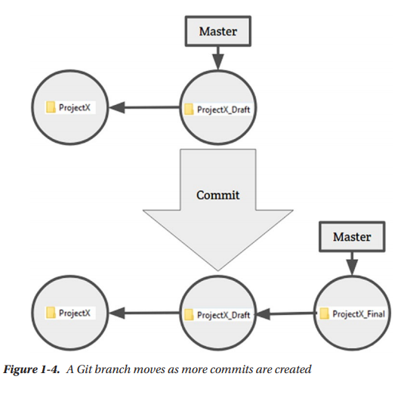

Git uses a branch named master as its default. This means that we expect the master branch to be the main source of truth and the most important branch. In other version control systems, this could be called Trunk or Mainline. There are a few conventions that expect the default branch to be named master, and I highly recommend that you do not name your single source of truth branch to something other than master. Do so at your own peril. It is highly unlikely to solve any real problems.

In Git, we can have many branches, but it is recommended that we have a low amount of long-lived or permanent branches.
In my experience, the need for anything more than one permanent branch is artificial and construed. Having many branches often causes too complex workflows to arise, generating overhead in the development process.
Complex workflows are often introduced to create higher-quality, safer integrations, and other things of that ilk, but often, they are at best treating symptoms of deeper problems with the way of working in the software.
Setting Up Git and the Git Katas
Now that we have introduced the foundational vocabulary, we are going to make sure that everything is set up. Then, we can dive in and get our hands dirty on actual Git repositories and do some deliberate practice there. I tend to put everything in Git repositories, so you will not be surprised to learn that the exercises that we are going to be using in this book are delivered to you as a Git repository.

That is why we will be introducing our first command now. As mentioned before, Git is a distributed version control system. In your day-to-day life, you are very likely to collaborate on a repository that is hosted in the cloud or on premise on one of the many repository managers. We use the Git clone command to obtain a local copy of the repository to do our work in.

Git Clone
A clone is a two-step command: first, it downloads the Git repository, and then, it checks out the most recent commit on the default branch of the repository into the workspace
There are many variants of the clone command, but in its basic form, it looks like this: git clone .
An example of this is git clone https://github.com/eficode-academy/git-katas.git git-katas.
This will download the repository containing the git katas into the folder git-katas/.git/ and check out the workspace of the newest commit on the master branch into the folder git-katas.

The .git Folder
We will not dive into details on the many things that are in the .git folder, but for the purpose of intuition, let it suffice that it, among other things, contains

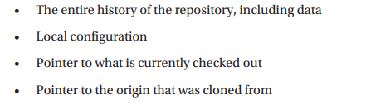

Checking Git is working
First up, we are going to open a command line and run the git --version command to check everything is working as expected.
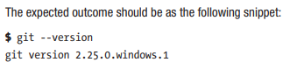
Retrieving the Git katas
- go to your required directory
- Clone the Git katas using the clone command: git clone https://github.com/eficode-academy/git-katas.git git-katas
- cd to the git-katas folder and use ls to see the list of exercises.

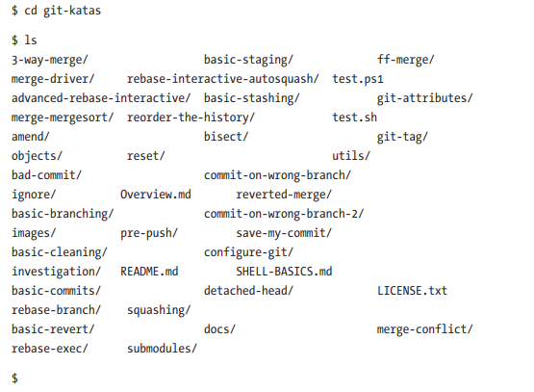
Getting Our Bearings in a Repository
We will be introducing the commands: status, log, and checkout.
We will cover status in depth, but log and checkout are both big commands that we will introduce gradually over the course of the book.
Git Status
“If you are in doubt of what is going or, or what you are supposed to do, just run git status and Git will tell you.” While this is a slight exaggeration, all inquiries should start with a git status.

Git status tells you about the state of your workspace and how it compares to what is currently checked out. If the workspace is identical to what is checked out, the workspace is said to be clean.
If the workspace contains changes, of any sort, the workspace is said to be dirty.
Changes can be modified, deleted, added, or renamed files.
Git also has a notion of ignored paths, and from the perspective of Git, changes in ignored paths do not make the workspace dirty. How a file moves through these states is shown in Figure 1-5
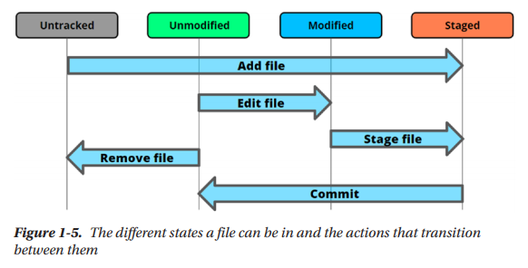

Git Log
. Git log is the most basic way we can look at the history of our repository. While Git log is a basic command, it is also one of the most configurable ones, and the number of flags and arguments can be intimidating.

If you look in the following listing, you see a run of log without any commands and flags, configured with the default Git 2.25 installation. In this repository, there are only a few commits, on a single branch, and a single tag. Commits come in reverse chronological order, meaning that the newest commit will be the one printed first and then following the parent pointer of each commit until we reach the first commit.
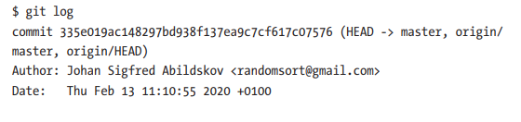
Git log --oneline
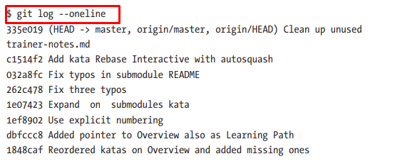

If we are missing the references from the preceding view, it can be due to an outdated version of Git.
In that case, we can use the flag --decorate to have Git annotate the commits with the relevant pointers. Our command then becomes git log --oneline --decorate.

As long as we are only using one branch and thus have a linear history with no divergent threads of development, this should be enough for our use. When we look into more complex histories in Chapter 3, we will add some more tools to our log command.

To view commits logs upto 3 commits
Git log –online -3

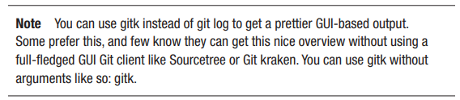

Chapter # 2
Building commits:
Commits are the basic building blocks of our history, both containing
- the actual content of our versions
- the parent pointers that define our history.

What’s in a Workspace
Workspace:
In software development, the place where we store project-specific files with our code is commonly called the workspace. Here author talking about workspace in our local system.

Notice how the .git folder containing the Git repository is hidden. It is a common convention to have files and folders that start with a . be hidden.
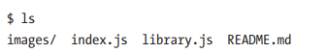

As mentioned, our workspace can be either dirty or clean, when compared to the currently checked-out commit on the repository. Dirty is not a bad word; it simply implies different.
This difference is of course a good thing because those are the changes that we have made, but just have not committed yet.

Another source that can make our workspace dirty is auto generated files and build artifacts. We will later cover how we can make Git ignore certain paths.

Clean work space
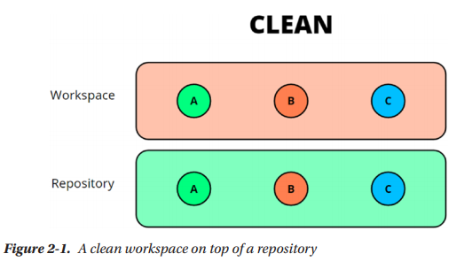
Dirty work space
As we have change the file A.
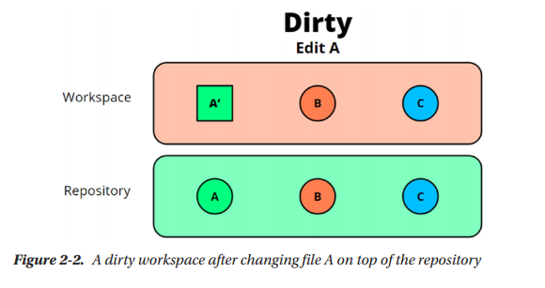

What is head in Git?
The HEAD points out the last commit in the current checkout branch.
The HEAD can be understood as the "current branch."
When you switch branches with 'checkout,' the HEAD is transferred to the new branch.
